Design flaws led to 2013 lithium-ion battery fire in Boeing 787: U.S. NTSB

By Reuters

December 2, 2014 4:32 AM PST Updated 9 years ago

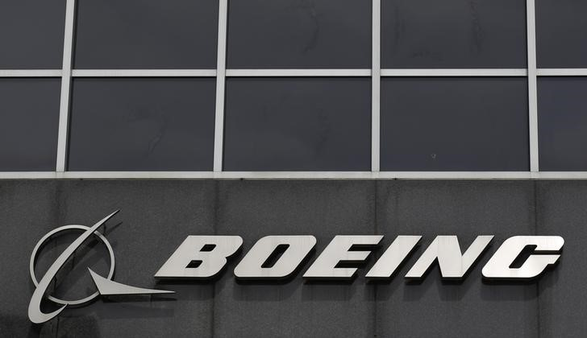

The Boeing logo is seen at their headquarters in Chicago, April 24, 2013. REUTERS/Jim Young [*Purchase Licensing Rights, opens new tab*](https://www.reutersagency.com/en/licensereuterscontent/?utm_medium=rcom-article-media&utm_campaign=rcom-rcp-lead)

WASHINGTON (Reuters) - A lithium-ion battery that caught fire aboard a parked Boeing 787 in 2013 in Boston had design flaws and it should not have been certified by the U.S. Federal Aviation Administration, U.S. accident investigators said on Monday.

The National Transportation Safety Board said the battery, manufactured by GS Yuasa Corp, experienced an internal short circuit that led to thermal runaway of the cell. This condition caused flammable materials to be ejected outside the battery's case and resulted in a small fire, the NTSB said in its report on the incident.

The agency said its investigators found a number of design and manufacturing concerns that could have led to the short circuiting, including the presence of foreign debris and an inspection process that could not reliably detect defects.

"We are looking at the report from the NTSB, and until we have examined its findings we don't wish to comment," a spokeswoman for GS Yuasa said. The Japanese battery maker's shares dipped as much as 3.2 percent in Tokyo after the NTSB released its findings.

No one was hurt in the January 2013 incident aboard a Japan Airlines plane. The fire broke out while the 787 Dreamliner was parked at Boston's Logan Airport after passengers and crew had departed.

Boeing redesigned the battery and charger and designed a steel box to contain fires and vent hot gasses outside the plane.

"We consider the improvements made to the 787 battery system can ensure safe operation as designed," a spokesman for Japan Airlines said.

Another battery overheated on an All Nippon Airways plane later the same month, prompting regulators to ground the global fleet until April that year.

The Japan Transport Safety Board (JTSB), which investigated that overheating, said in a report in September that engineers failed to identify the possibility that a short circuit in one cell could spread because they did not appropriately simulate the power unit's on-board configuration. It also pointed to the possibility of cold winter air damaging the battery cells and electrical wiring.

Boeing said it agreed with the NTSB's conclusion that a short circuit led to the fire in Boston.

"We remain confident in the comprehensive improvements made to the 787 battery system following this event, and in the overall performance of the battery system and the safety of the airplane," the company said in a statement.

The batteries are widely used in cars, laptops and smartphones and have a tendency to overheat through processes that are not well understood by scientists.

Because the battery was a new technology, the FAA had required Boeing to demonstrate its safety in aircraft.

The NTSB faulted Boeing for ruling out the possibility of thermal runaway in its safety assessment of the battery, and it criticized the FAA for certifying the battery without thoroughly scrutinizing the potential danger.

The NTSB said it is recommending that the FAA improve the guidance it provides to the aircraft industry and to FAA engineers on safety assessments involving new technology.

"The FAA already has implemented many of the NTSB's recommendations about modifications in testing, safety standards and design as part of the 2013 certification of the 787's redesigned battery system," the FAA said in a statement on Monday.

Reporting by Eric Beech; Additional reporting by Tim Kelly in TOKYO; Editing by Mohammad Zargham, Jim Loney and Eric Walsh